Assignment 21 (March 13 - March 18)

1. Given the demand and supply function for the cobweb model as follows, find the intertemporal equilibrium price, and determine whether the equilibrium is stable:
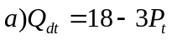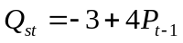
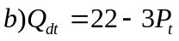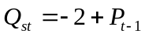
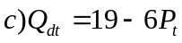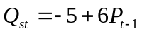

2. If a market model with inventory has the following numerical form:
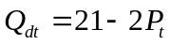
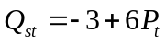
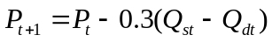
find the time path 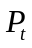 and determine whether it is convergent.

3. Solve the following linear program:

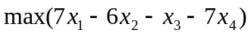
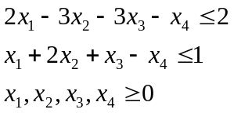

4. Solve the following linear program:

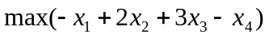
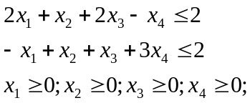

5. An economy produces an income 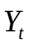 at year t. In the absence of governmental expenditures the following identity is valid: 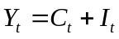, where 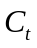 is the consumption in year t and is the investment in year t. The investment equals to 75% of the previous year income 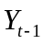 and there is no autonomous consumption. Let denote the marginal propensity to consume by k.
Derive a first order difference equation for the consumption . Solve this equation and find the condition upon k for which consumption will raise from year to year. If k = 0.32, 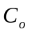= 100, sketch and describe the solution for t=0, 1, 2, ... Determine when, if ever, the consumption in a year first falls bellow 10.

